**Input:**

F(x): 2x4-3x2+3x-4

x0 = -2

EPS= 0.00001

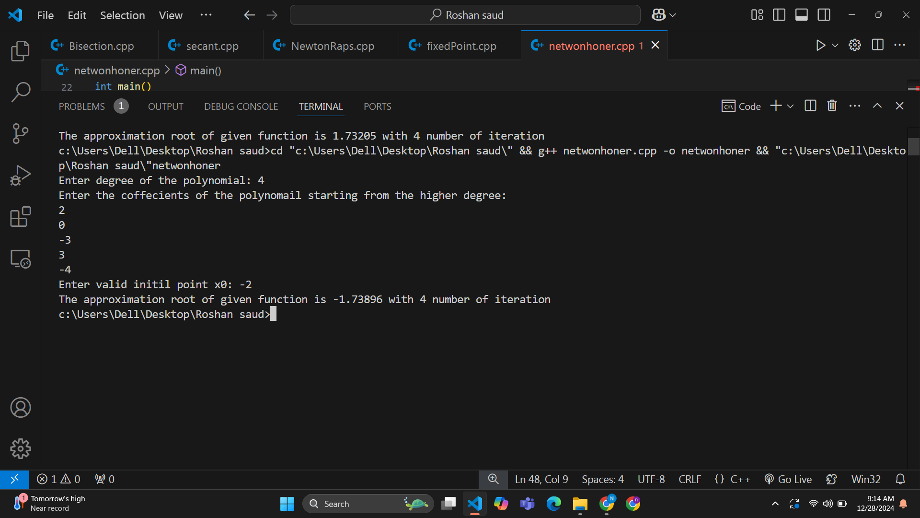**Output:**

**Input:**

F(x): x2 - 3

x0 = 1.5

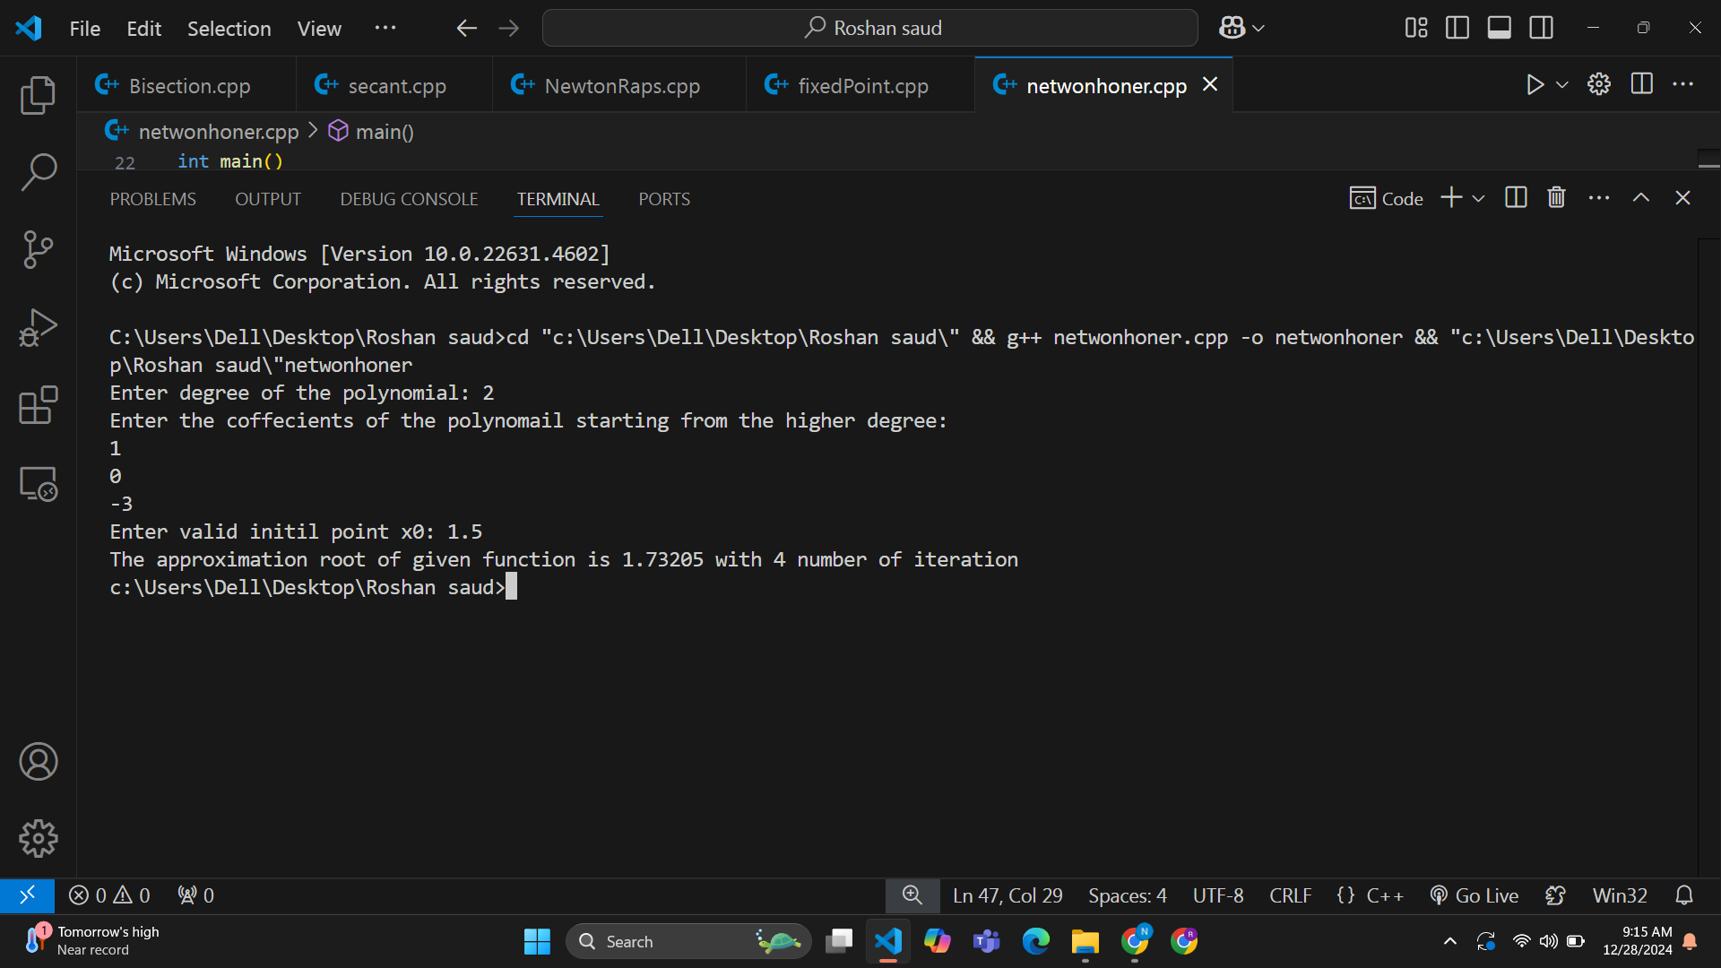EPS= 0.00001 **Output:**